Appendix A. BPMN Workflows

Appendix A.1. Admission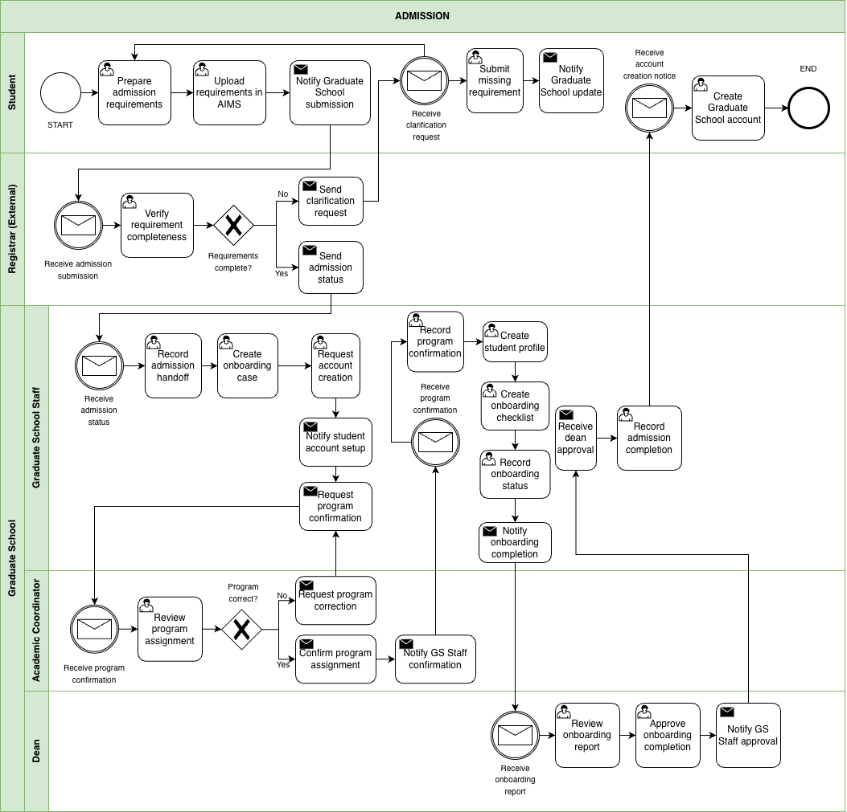

Appendix A.2. : Enrollment
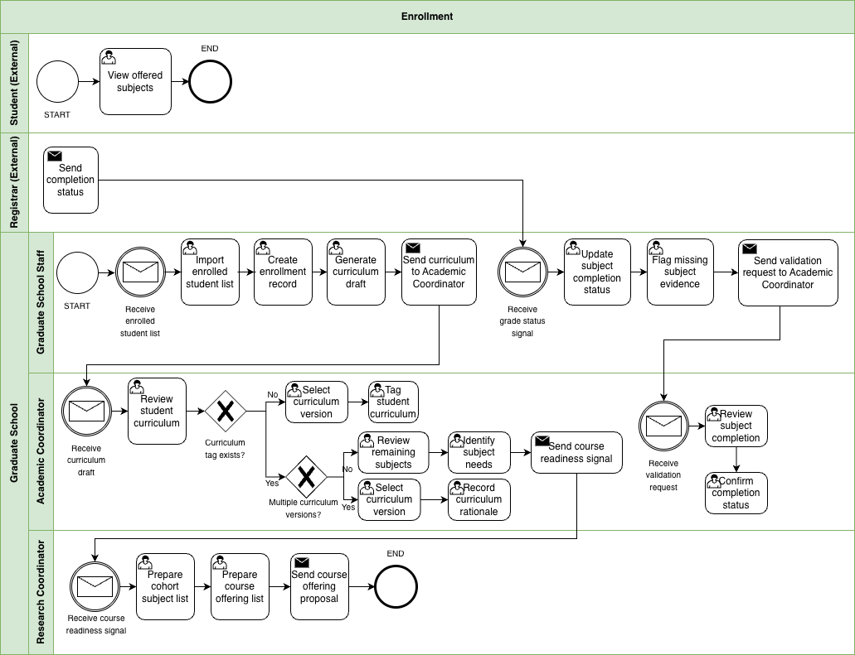

Appendix A.3. Course Adjustments
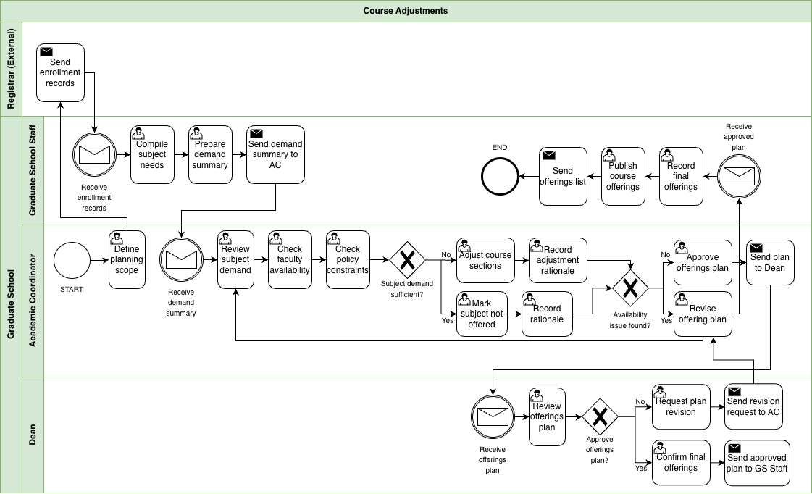

Appendix A.4. Coursework
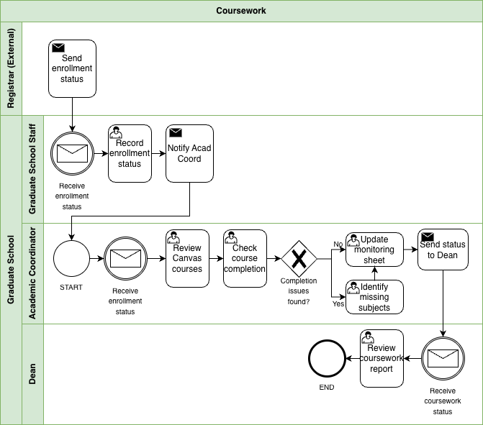

Appendix A.5. Leave of Absence and Readmission
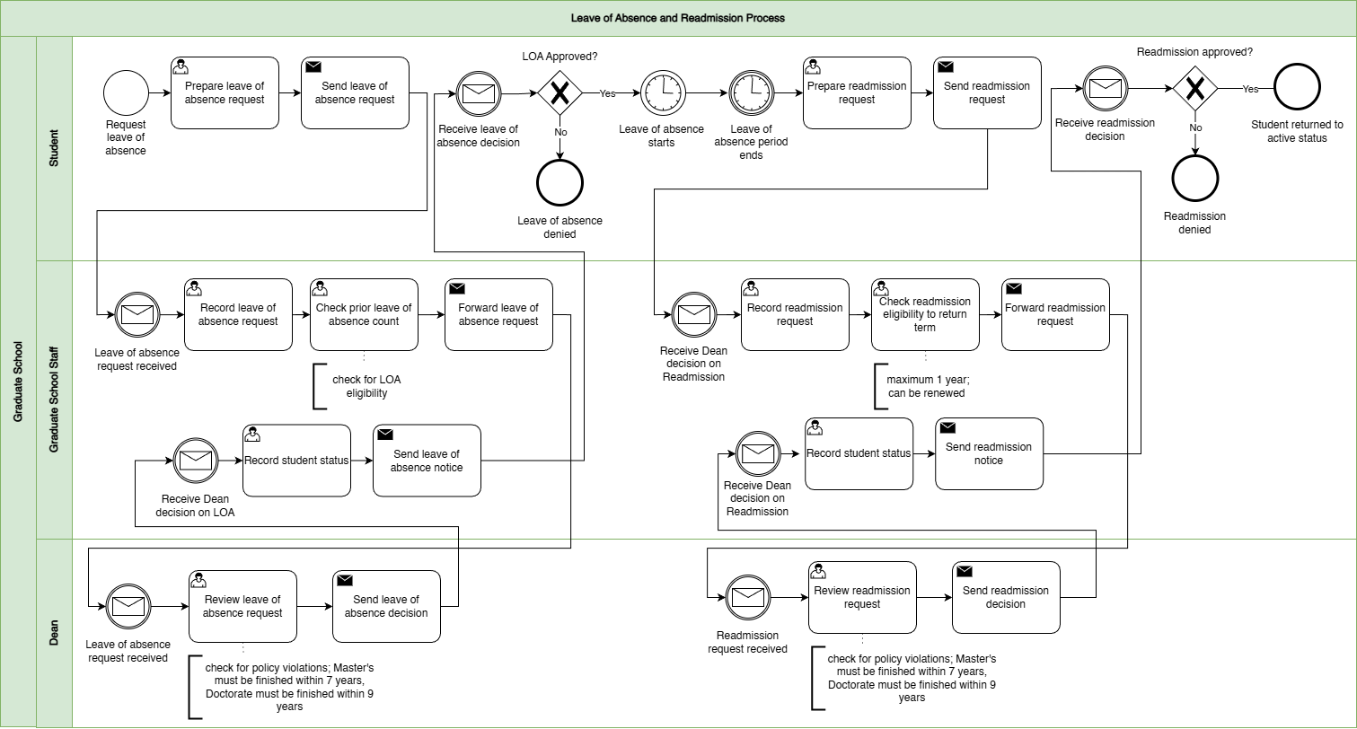

Appendix A.6. Title Defense
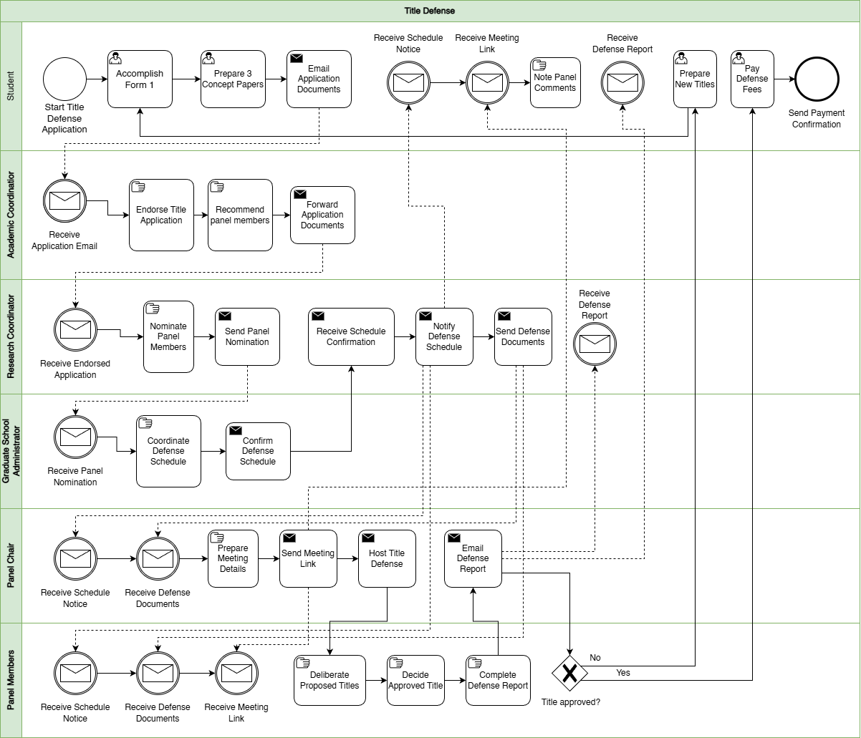

Appendix A.7. Advisor Designation
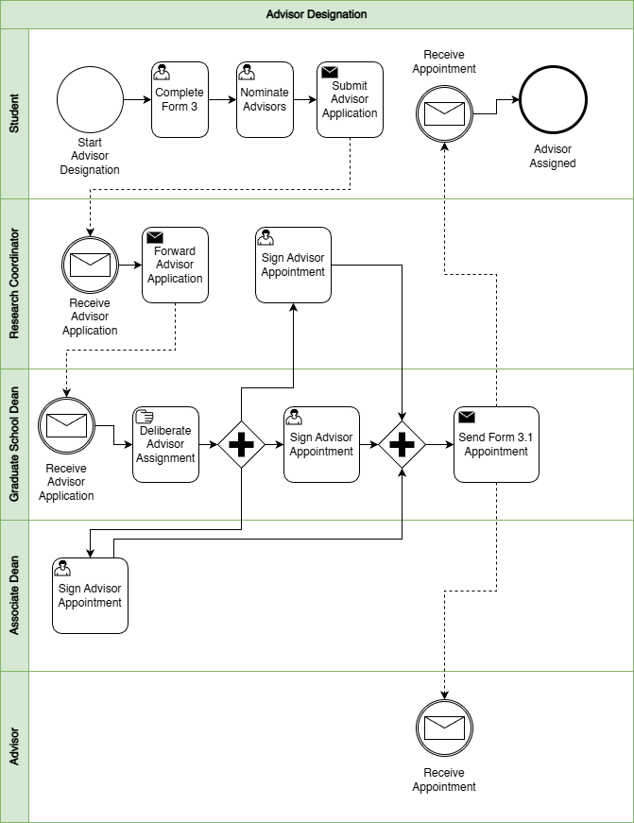

Appendix A.8. Thesis/Dissertation Pipeline (Milestone Workflow)
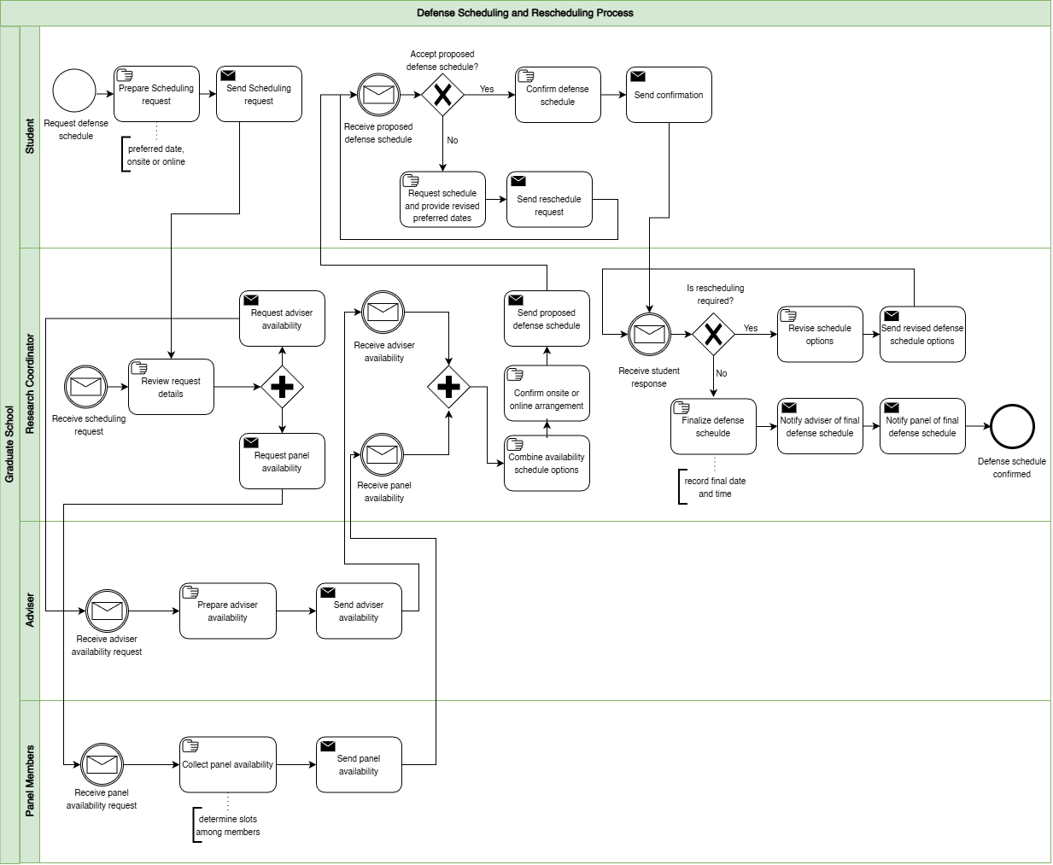

Appendix A.9. Defense and Revisions
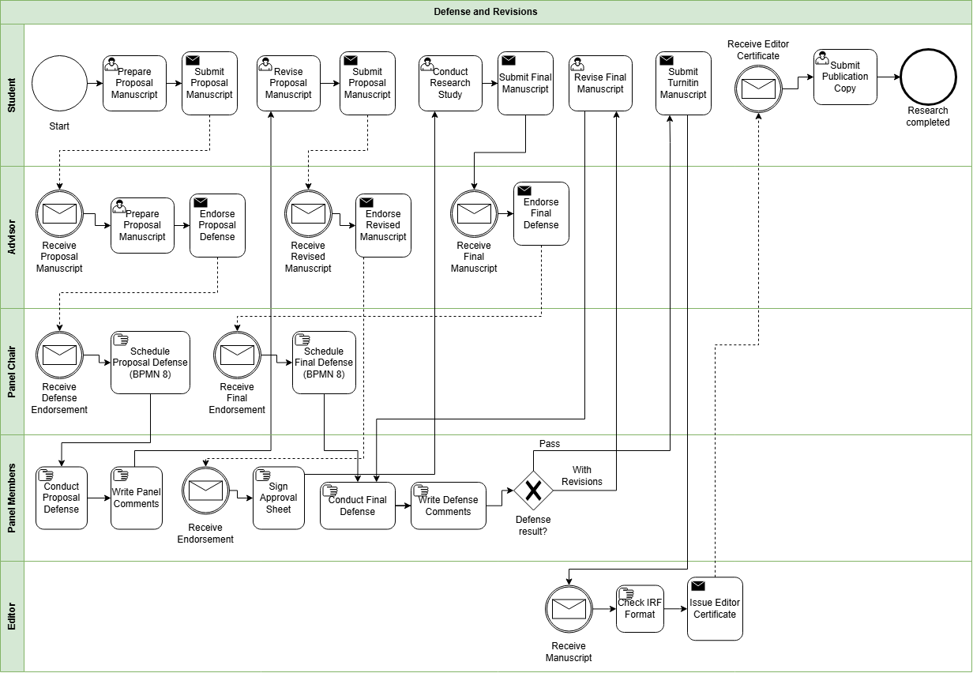
Appendix A.10. Practicum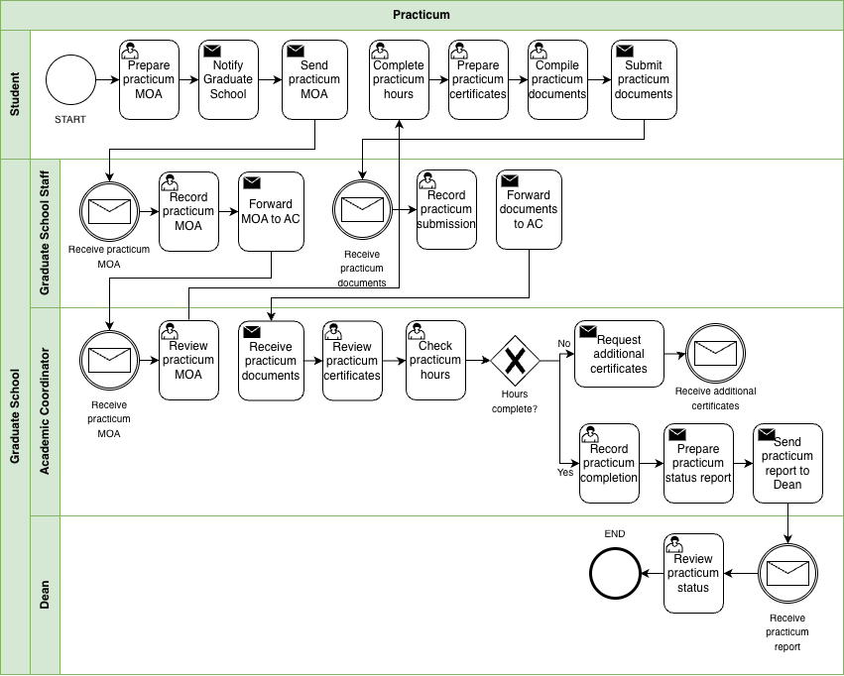
Appendix A.11. Withdrawal
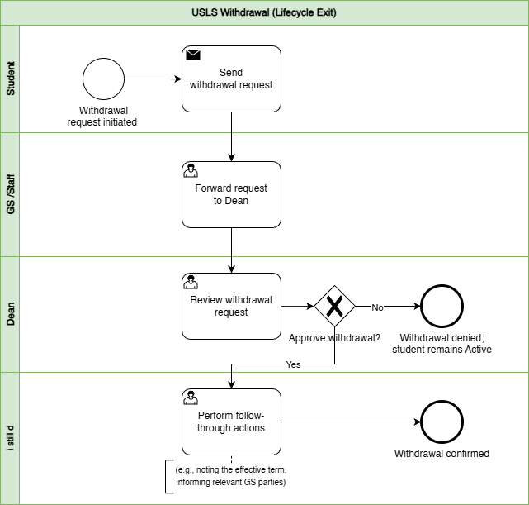
Appendix A.12. Graduation
